1. Describe in own word the words:

a. Dataset: **- or TUPLE: All characteristic values of an element and ENTITY QUANTITY: all datasets in a table (or entity).**

b. Domain: **The range of values that an attribute can have (Ex. Gender can have only MALE or FEMALE)**

c. Null value: **It indicates that the attribute has no attribute value. It is NOT the value ZERO.**

2. Describe the following picture (step by step – arrows) and describe the advantages.

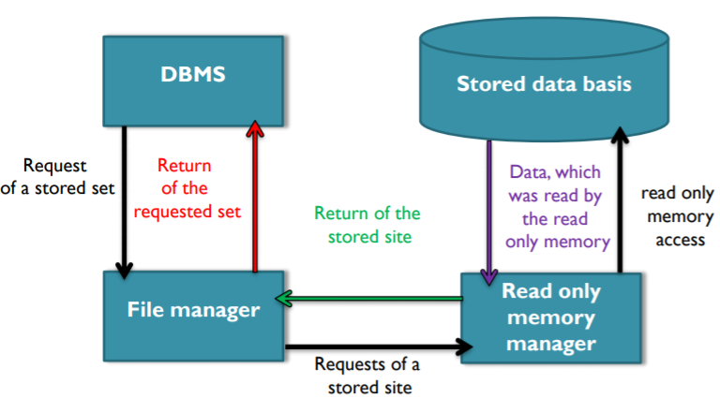

3. Analysis the table of Exercise 2.6

a. Which kind of clustering would be ideal?

**Because information is stored on 3 separate tables (Book, Author, Publisher) and most information on Author and Publisher is accessed through the table Book, all the tables will be stored next to each other by use of Inter-file Clustering.**

b. Describe the difference between "Intra-File-Clustering" and "Inter-File-Clustering"!

**Intra-file clustering: records in a single file are stored close to related records in the same file (Ex. if suppliers are normally ordered by their supplier number then each supplier would be stored to the supplier with the next highest supplier number).**

**Inter-file clustering: records from one file are stored close to records from another file (Ex. a shipment from a shipments file would be stored close to the supplier of the shipment).**

4. A database is separated in three levels. Describe them in your own words.

**a. Internal level: is the physical storage for the data. How the data is stored and the possibilities to access it (Ex. Through pointers).**

**b. External level: how the user can see or interact with the data (different views) (Ex. A programmer uses JAVA, C/C++, Python, etc., a data-manager uses a DBMS or Management Console, etc.)**

**c. Conceptual level: the connection between the internal and external levels. Defines how the data is structured in tables, the relations between entities, etc.**

5. In which level do we find the data language. Explain why the data language can’t be in another level!

**The data language works on processes which have to do with data and operations and controls all actions concerning database access. Because of this it must be on the external level, that describes how a user interacts with the data.**

6. The data language contains two important parts. Which are they? Make for each part an example.

**a. Data Definition Language (DDL): It is used to create and modify the structure of database objects in database. Examples: CREATE, ALTER, DROP statements**

**b. Data Manipulation Language (DML): It is used to retrieve, store, modify, delete, insert and update data in database. Examples: SELECT, UPDATE, INSERT statements**

7. We discussed about the „logical “and „physical “independence. Describe what is meant with it and tell me the advantages!

**a. Logical data independence: the DBMS guarantees it, when the users and operators software doesn’t recognize changes of the conceptual level and are not affected by it. Advantages: Can improve performance and addition or removal of entities, attributes or relationships require no changes to the existing application programs.**

**b. Physical data independence: the DBMS guarantees it, when the users and operators software doesn’t recognize changes of the internal level and are not affected by it. Advantages: Allows changing the physical structure of the database (storage devices, file organization, etc.).**

8. Write at least three important tasks of a database administrator and describe them.

**a. Design of the conceptual level: the conceptual scheme and logical database design**

**b. Design of the internal level: the internal scheme and physical database design**

**c. User support: creation, optimization, modification of database entities.**

**d. Define data constraints: rules with which the integrity of the data pool is ensured.**

**e. Data backup: regulation and implementation of archiving, securing and backing up of data.**

**f. Reorganization of the data pool: update the index tables in case of data archiving.**

9. The DBMS has to cover an import area! Describe at least one of them